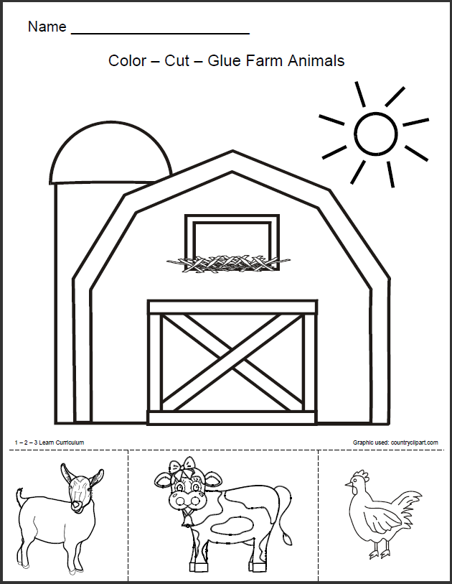
https://pl.pinterest.com/pin/85709199130952499/

