WINTER TIME

HAT

BROOMSTICK

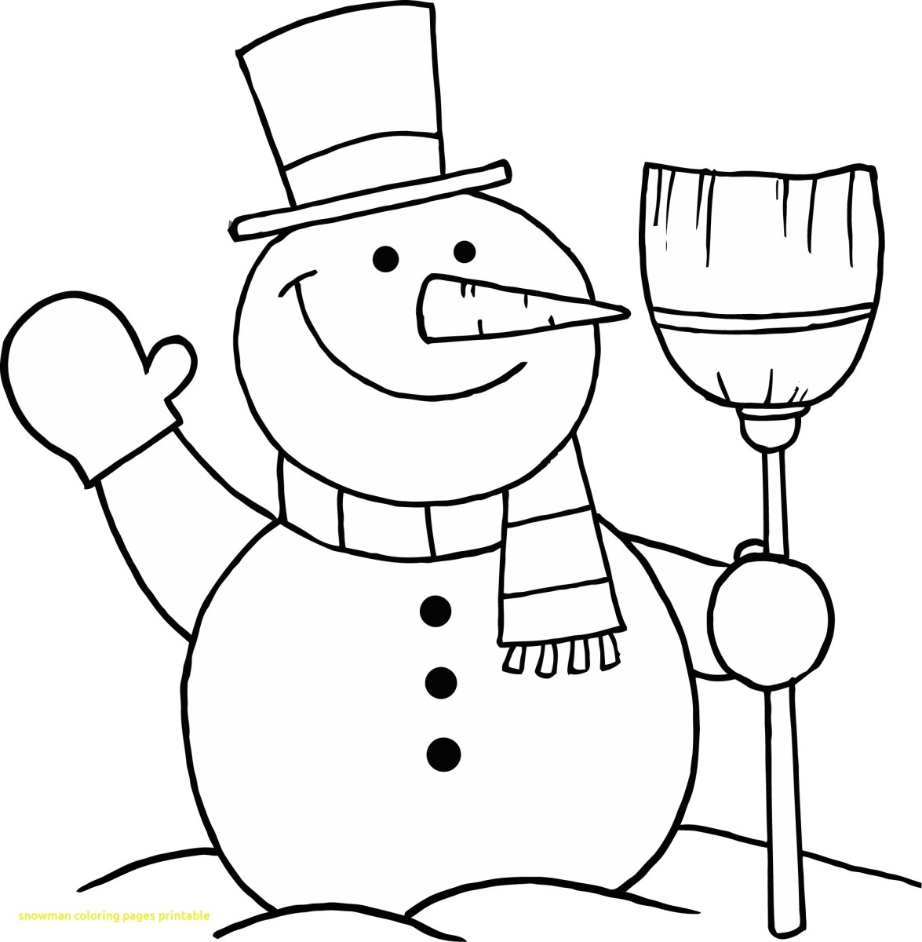

TALL

FAT

SNOWMAN